**Chapter 4**

**CONCEPTUAL FRAMEWORK**

This study entitled Mobile Information Notifier for LSU-Ozamiz is an android based notification system that provides awareness to all the students, faculty and staff of La Salle University Ozamiz in a quick and real time process. All the events handled by the Supreme Student Council of La Salle University Ozamiz could easily be disseminate to all the students, faculty, and staff ahead of time inside or outside of the school campus. Users of the mobile application are required to log in using their ID number and pin including the college & office secretaries and SSC of LSU for the web based system.

After the authentication process for the college & office secretaries, they can now create and save any information about any upcoming events that will be saved directly to the database of the web server. The data can now be automatically sent to all the android phone of all the student and employees in a form of pop up notification using the android notifier application.

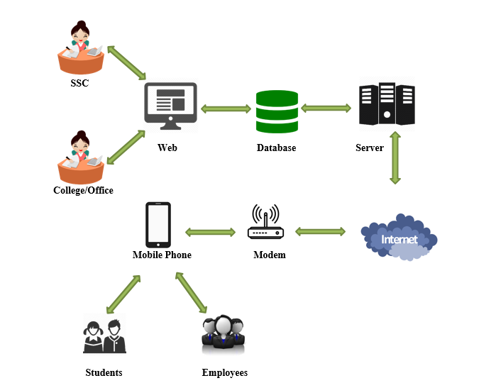

**CONCEPTUAL FRAMEWORK**

**Figure 1.**

As shown in the image above, the college/office secretaries and SSC has the privilege to input any data that will be saved to the database of the web server. All the data about any upcoming events will be sent automatically to the mobile phone through a wireless internet connection producing a notification that notifies the user about the specific info of an upcoming event. The college & office secretaries as well as the SSC can also send notifications to each other producing a message to their web user interface.

**Software applications and programming languages used:**

The following are the software and programming languages used by the proponents in developing the system.

**Android Studio 2.2.1**

The Android Studio is an integrated development environment (IDE) for Android platform development based on Jet Brains’ IntelliJ IDEA software. Using java programming language, the researchers developed the mobile application using this IDE.

**Laravel Framework**

Created by Taylor Otwell, Laravel is a free and open source PHP web framework and intended for the development of web applications following the model view controller (MVC) architectural pattern. It attempts to take the pain out of the development of any websites by making the common tasks easy and is used by many developers for their web projects, such as authentication, routing, sessions, and caching.

**Sublime text editor**

A proprietary cross-platform source code editor that natively supports many programming languages and markup languages, and its functionality can be extended by users with plugins, typically community-built and maintained under free-software licenses.

**Xampp**

Developed by the Apache Friends, Xampp is a free and open source cross-platform web server solution stack package, it makes transitioning from a local test server to a live server extremely easy as well. Cross-Platform(X) Apache (A), Maria DB (M) ,PHP (P) and Perl (P) that’s what XAMPP stands for.

**Adobe Photoshop CS6**

Adobe Photoshop CS6 is a software application used for almost any kind of image editing, produce high quality of photos in JPEG or PNG image file format and is primarily use by professionals for various image designs including company logos.

**System Development Model**

The researchers used the Waterfall Model to develop the system. This will help to the development of the proposed project.

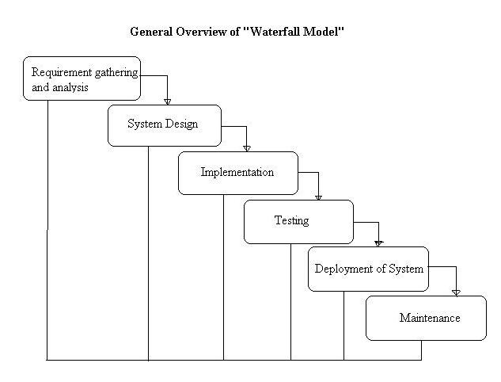

Mobile Information Notifier for LSU-Ozamiz Systems Development Life Cycle

**Figure 2.**

The Mobile Information Notifier for LSU-Ozamiz will be put into action using the waterfall model. The waterfall model is a popular version of SDLC for software engineering. Development using waterfall model has distinct goals for each phase of development. It is considered the classic approach to the SDLC, the waterfall model describes a development method that is linear and sequential. The waterfall model is like a river that flows from top to bottom flowing through the different phases of software development. This means that one phase must be completed first in order to proceed to the next phase ensuring that all software development phase must be followed accordingly.